**Worksheet – 1.2**

**Student Name:** Vivek Kumar  **UID:** 21BCS8129

**Branch:** BE-CSE (LEET) **Section/Group:** 808/B

**Semester:** 4th **Date of Performance:** 18/02/2022

**Subject Name:** Computer Network Lab **Subject Code:** 20CSP-257

**1. Aim/Overview of the practical:**

Implement all the networking commands and show their working as output.

**2. Task to be done/ Which logistics used:**

* Implementation of Ping, Ipconfig, Tracert, Arp, Netstat, Nslookup, Hostname and Pathping etc.

**3. Steps for experiment/Code with Result/Output:**

**Ping:**

*Syntax:* ping <<destination host IP or name>>

**Code: ping google.com**

**Output:**

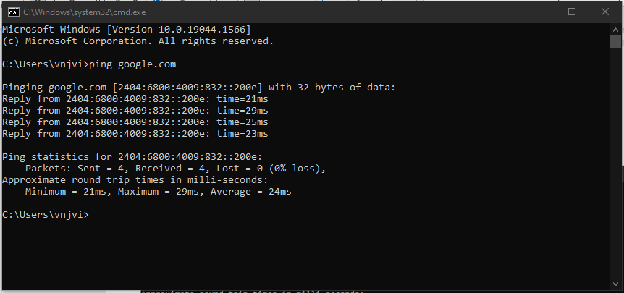

**IPConfig:**

*Syntax:* ipconfig <<parameter>>

**Code: ipconfig /all**

**Output:**

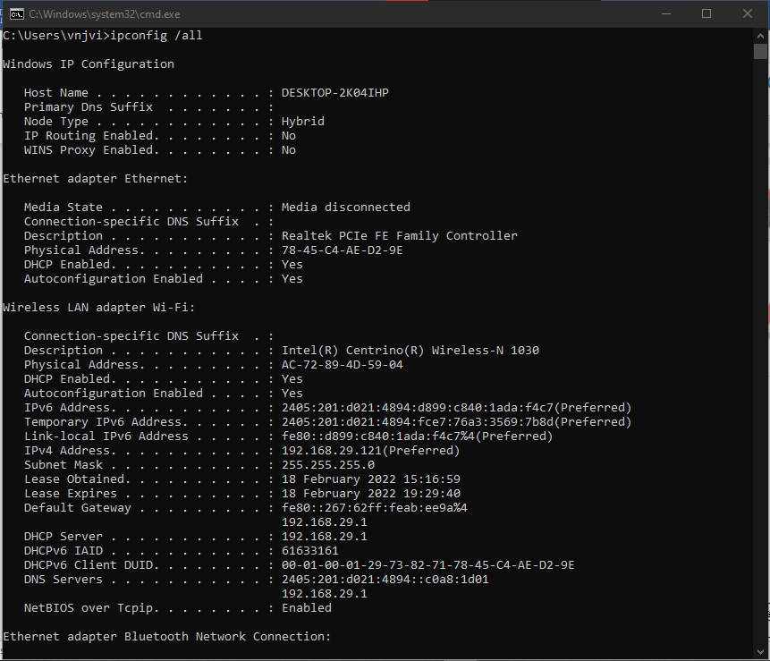

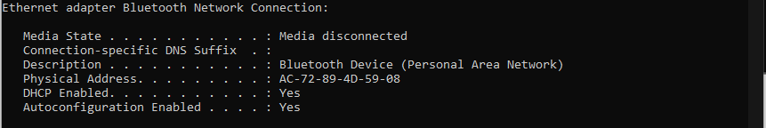

**Tracert:**

*Syntax:* tracert << destination name or IP address >>

**Code: tracert www.google.co.in**

**Output:**

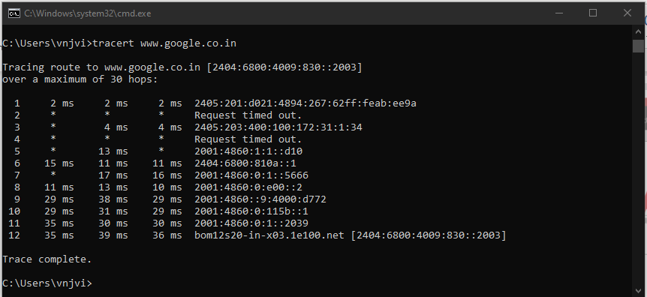

**Arp:**

*Syntax:* arp << Options >>

**Code: arp -a** *&* **arp -a -N 192.168.29.121**

**Output:**

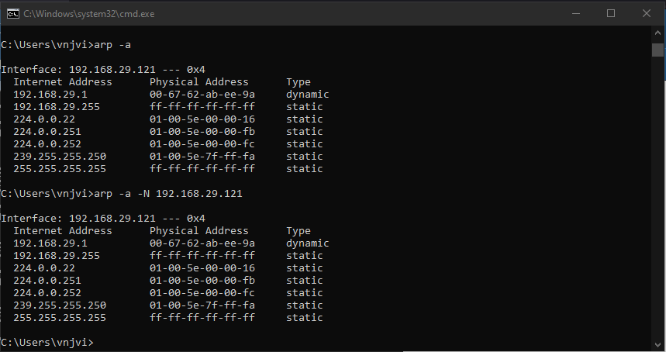

**Netstat:**

*Syntax:* netstat << Options >>

**Code: netstat**

**Output:**

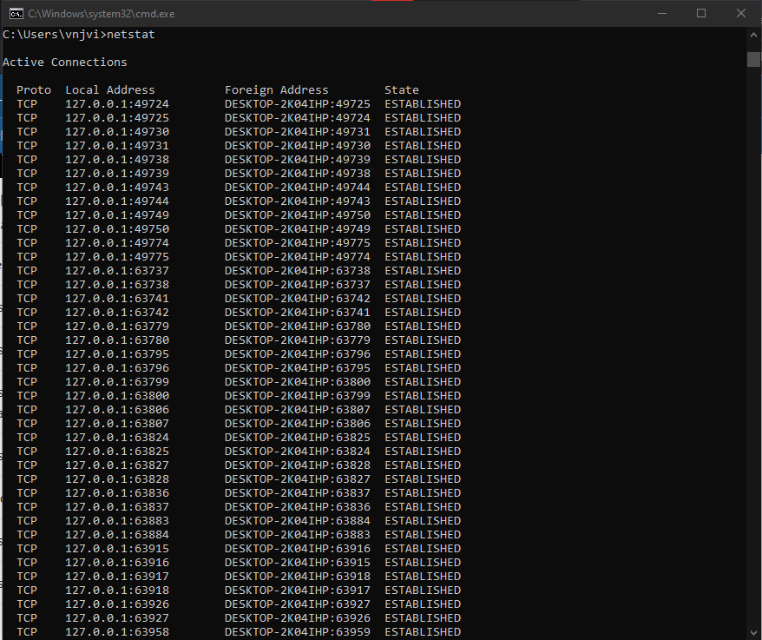

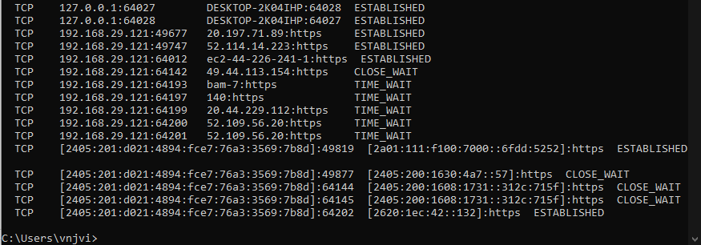

**Nslookup:**

*Syntax:* nslookup <<exit | finger | help | ls | lserver | root | server | set | view>> <<options>>

**Code: nslookup**

**Output:**

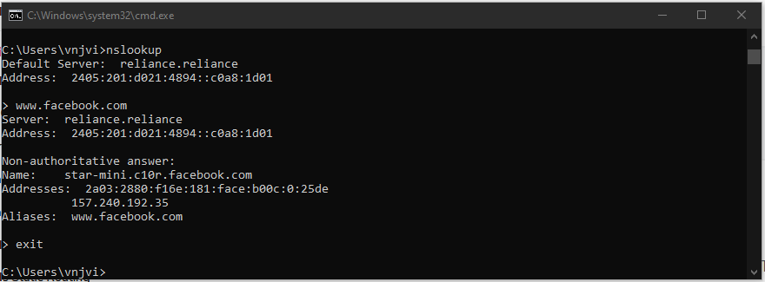

**Hostname:**

*Syntax:* hostname <<options>>

**Code: hostname**

**Output:**

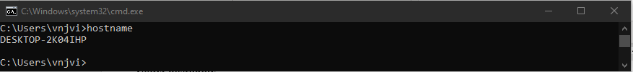

**Pathping:**

*Syntax:* pathping [/n] [/h <maximumhops>] [/g <hostlist>] [/p <Period>] [/q <numqueries> [/w <timeout>] [/i <IPaddress>] [/4 <IPv4>] [/6 <IPv6>][<targetname>]

**Code: pathping /n www.google.com**

**Output:**

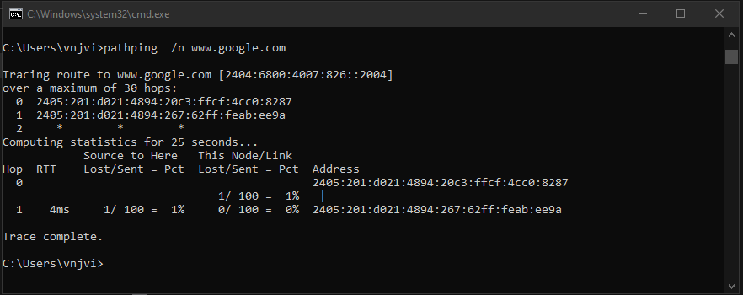

**Learning outcomes (What I have learnt):**

**1.** Studied about various type of Networking command

**2.** Executed all type of networking command and observed the output.

**Evaluation Grid (To be created as per the SOP and Assessment guidelines by the faculty):**

|  |  |  |  |
| --- | --- | --- | --- |
| Sr. No. | Parameters | Marks Obtained | Maximum Marks |
| 1. |  |  |  |
| 2. |  |  |  |
| 3. |  |  |  |
|  |  |  |  |